Module 3(React Js)

Q-1) What is React Js?

Ans-1) React JS is a declarative, efficient, and flexible JavaScript library for building reusable UI components. It is an open-source, component-based frontend library responsible only for the view layer of the application.

Q-2) What is NPM in React Js?

Ans-2) npm is an abbreviation used for the node package manager. It is a package manager for JavaScript. It is the default package manager that comes with NodeJS when you install it.

Q-3) What is Role of Node Js in react Js?

Ans-3) Node JS provides NPM to install open-source packages and also people prefer to use JSX format while writing React JS. So Node JS provides efficient environment for creating React by providing useful tools.

Q-4) What is CLI command In React Js?

Ans-4) React has its own command-line interface (CLI) commands. However, these CLI commands are currently only used to create a passable version of a react application using the command line.

Q-5) What is Components in React Js?

Ans-5) Components are independent and reusable bits of code. They serve the same purpose as JavaScript functions, but work in isolation and return HTML. Components come in two types, Class components and Function components, in this tutorial we will concentrate on Function components.

Q-6) What is Header and Content Components in React Js?

Ans-6) A header is a section at the top of a page that displays site name and navigation. React is the most popular frontend library for developing component-driven user interfaces. It's used for developing single page, mobile, and server-rendered applications.

Code:

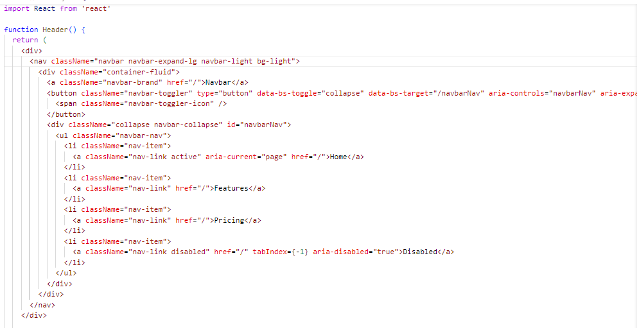

Output:



* Content Components: Content Components are sections of content that can be added to multiple pages. The page template determines what Content Components are allowed on a page.

Code:

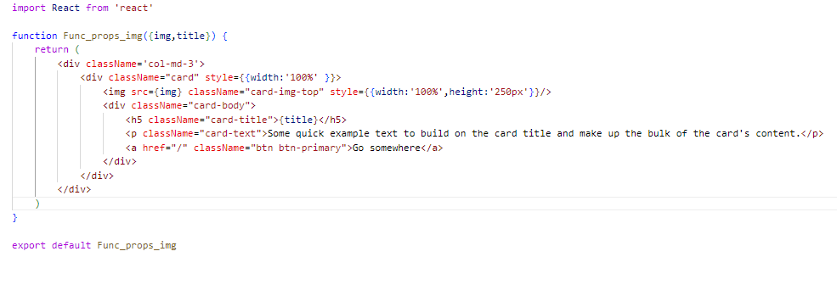

Output:

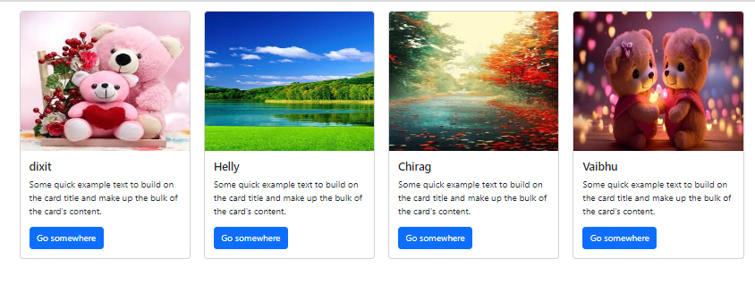

Q-7) How to install React Js on Windows, linux Operating System?

Ans-7) Installing React.js on Windows and Linux:

Step 1: Install Node.js and npm.

* Windows:
* Visit the Node.js official website and download the Windows installer.
* Run the installer and follow the prompts to install Node.js and npm.
* Linux:
* On Linux, you can install Node.js and npm using a package manager like ‘apt’ (for Debian/Ubuntu-based systems) or ‘yum’ (for Red Hat/Fedora-based systems).

Step 2: Create a React App

After installing Node.js and npm , you can create a new React app using Create React App.

* Open a terminal or command prompt.
* To create a new React app, run:
* npx create-react-app my-react-app
* Replace ‘my-react-app’ with your preferred app name.
* Navigate into your newly created app directory:
* cd my-react-app

Q-8) How to install NPM and How to check version of NPM?

Ans-8) To check the version of npm installed on your system:

* Open a terminal or command prompt.
* Type the following command:
* Npm install
* For version check command npm –v

Q-9) How to check version of React Js?

Ans-9) Open the ‘package.json’ file in the root directory of your project and look for the ‘react’ dependency.

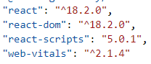

Q-10) How to change in components of React Js?

Ans-10) There are several ways to change components in React JS, depending on the nature of the change and your desired functionality:

* Updating State:
* If the change involves updating the component’s internal data, use the useState hook to manage the state and trigger a re-render when the state changes.
* Update the state using the setState function within event handlers or other logic that modifies the data.

The component will re-render with the updated state, reflecting the changes in the UI.

* Passing Props:
* If the change involves modifying the component based on external data, pass the data as props from the parent component.
* Update the props in the parent component when the data changes.
* The child component will receive the updated props and re-render with the new information, reflecting the change in the UI.
* Conditional Rendering:
* Use conditional statements like if or ternary expressions (? :) to selectively render different content based on props or state.
* This allows you to dynamically show or hide parts of the component based on specific conditions.

Q-11) How to Create a List View in React Js?

Ans-11)

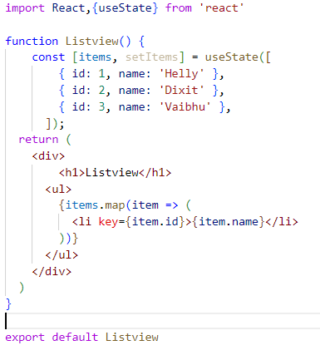

Output:

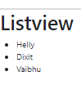

Q-12) Create Increment decrement state change by button click?

Ans-12)

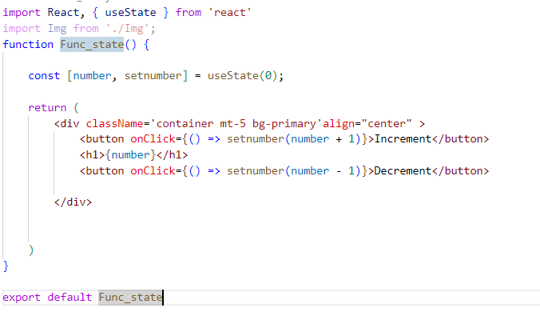

Output:

